Updates: Bahrain, emboldened by international silence, sentences Nabeel Rajab to 3 years imprisonment
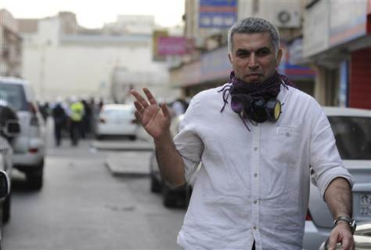
Bahrian's Human Rights Activits, Nabeel Rajab, gives a victory sign during an anti-government protest held in downtown Manama February 11, 2012. REUTERS/Stringer
Update 11 Dec 2012
Bahrain: Ruling by Court of Appeal passes a two-year in prison sentence on leading human rights activist Nabeel Rajab

Update 8 Nov 2012:
BAHRAIN: The verdict on Nabeel Rajab’s appeal expected on December 11
Update 18 Oct 2012
Bahrain: Rights of the defence undermined in Nabeel Rajab's trial
Update - 09 Oct 2012
Urgent Appeal: HRD Nabeel Rajab on hunger strike after the authorities refused to allow him to attend condolences of his mother
Update 2 Oct 2012
BAHRAIN: Ongoing judicial harassment and arbitrary detention of Nabeel Rajab
Bahrain- Court refuses to release human rights defender Nabeel Rajab
Update 12 Sep 2012
BAHRAIN: Human Rights Defender Nabeel Rajab to remain in detention, appeal trial to resume on September 27
Update 09 Sep 2012
Urgent appeal: Further details regarding the ill-treatment of Nabeel Rajab in prison of Bahrain
Update- 20 August 2012 21:00
It has been confirmed that Nabeel Rajab was in a solitary confinement during the past days. He has just called his family, and was speaking cautiously. When his wife asked if he was in solitary confinement, he answered yes. He also informed her that he was not allowed to have access to any newspapers. He said he was threatened that the line will be cut if he talked about any Bahrain news. The line was indeed cut in 2 minutes. His family is very concerned about his situation in the prison.
Sign Petition to Free Nabeel Rajab and all Bahraini prisoners of conscience from detentions in Bahrain!
Update- 20 August 2012 16:00
1- Nabeel Rajab has not called his family since the day he was sentenced on Thursday 16 August 2012. Other prisoners have been calling their families during the Eid holiday. In addition, an anonymous prisoner has called Said Yousif AlMuhafdha (BCHR Head of Monitoring) and informed him that Nabeel Rajab is in solitary confinement. While we have no way to confirm this news but the fact that Nabeel is not calling is raising our concerns.
2- Propaganda campaign: on Saturday 18 August 2012 a press conference was held by the minister of state for information affairs Mrs Sameera Rajab on which she claimed that Nabeel Rajab has been sentenced for inciting violence. (bna.bh/portal/en/news/521320) she also gave the same comments to tv news channels. This new accusation doesn't even match with the official accusations pressed by the public prosecution and heard at the court. The 3 accusations against Nabeel as listed in the indictment: 1-illegal gathering. 2-participating in illegal gathering. 3- calling for illegal gathering. Claiming that Nabeel Rajab has called for violence is untrue and it targets misleading the public.
16 August 2012
The BCHR and GCHR condemn in the strongest terms the sentence passed today against the detained human rights defender Nabeel Rajab by the Bahraini government on charges related to protesting. Rajab was sentenced to a total of three years imprisonment in three cases, to be immediately carried out.
Nabeel Rajab is the president of the BCHR, the director of the Gulf Center for Human rights, the vice president of FIDH, and on the advisory board for the MENA section in Human Rights Watch. He is a renowned human rights defender, and in 2011 he was awarded with the Ion Ratiu Democracy Award because he "has worked tirelessly and at considerable personal peril to advance the cause of democratic freedoms and the civil rights of Bahraini citizens".
The GCHR and BCHR believe that the only reason for targeting Rajab is to prevent him from continuing his legitimate and peaceful human rights work.
He is already serving a 3 months imprisonment sentence on charges of “libeling the citizens of the town of Muharraq over twitter”, another case of an ongoing campaign of judicial harassment against Rajab. He is in prison since the 9th July 2012 for this charge.
As reported by his son Adam, after the sentences were read out today Nabeel Rajab stated: “You can jail me for 3 years or 30 years, but I will not back down or retreat (from my human rights work)”
Rajab’s family had recently written an appeal to the international community regarding his imprisonment and 19 members of US congress had signed a letter demanding that Rajab and all other political prisoners be released.
Nabeel Rajab has been targeted for his work since several years back, however as his role become more vital in the last year in reporting the severe violations to human rights in Bahrain following the crackdown on protesters, the acts of retaliation by the regime against him has increased. He was dragged from his house after midnight on March 20, 2011 by masked security forces and he was beaten and harassed while blind folded and handcuffed. His house has been attacked with tear gas bombs twice in April and May 2011 putting the lives of his family at risk, the authorities never hold the responsible accountable for these attacks. (More details: bahrainrights.org/en/node/4144). Rajab was interrogated several time about the statements he gives on twitter, including an interrogation at the military prosecution in May 2011. He was banned from travel for several months in 2011 to stop him from participating in global human rights events and meetings. The regime also made it difficult for Rajab to work and ruined his personal business. Even his family members were targeted as his children were harassed in school and his wife, was sacked from her job after a campaign of harassment so that the regime could make sure that Rajab’s only income was stopped. However, since the beginning of 2012, the regime has moved to the practice of judicial harassments against Rajab, raising up to 5 cases against him until today, accusing him with “Participation in illegal gathering and calling for a march without prior notification”, “calling to illegal gathering over social networks”, “Insulting an official authority over twitter”, and defamation of AlMuharraq people over twitter. Rajab has been arrested and detained several times in the last few months starting May 2012 and the last arrest was on 9 July 2012. He has been convicted in all these cases by the Bahraini court and he was fined BHD 300 for insulting official authority over twitter on 28 June 2012, and received a total of 3 years and 3 months imprisonment sentences in the other cases.
For a longer history of harassments against Nabeel Rajab please read this report: bahrainrights.org/en/node/4144
It is important to note that the judiciary system in Bahrain is neither independent nor fair according to international standards. The BCHR and GCHR believe that these sentences are political decisions, and the judiciary system has been used as a tool of harassment against human rights defenders in specific, and pro-democracy protesters in general. (Please read: bahrainrights.org/en/node/5385)
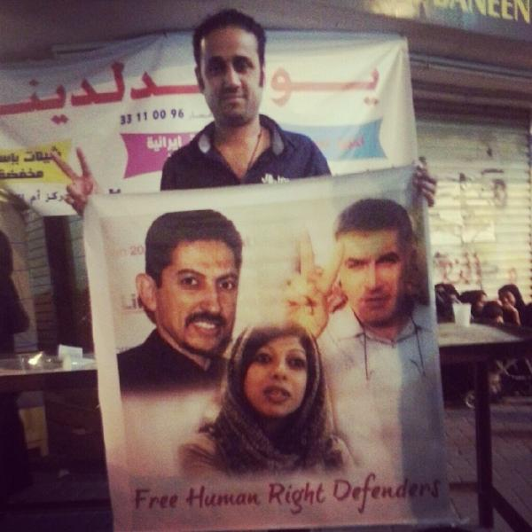
Said Yousif AlMuhafdha holding a banner of the detained defenders, few nights ago
In another case of escalation of attacks on human rights defenders, Said Yousif AlMuhafdhah, the head of Documentation Unit at the BCHR was attacked yesterday, 15th of August in front of his 3 and 5 year old daughters. This is what happened according to AlMuhafdhah:
“I was in the street adjacent to the checkpoint near Zayed City when I was stopped by traffic police in the middle of the highway. They told me that I am wanted by A’ali checkpoint. Then a police car (plate number: 6054) arrived and four of the police officers commenced beating, punching and slapping me in front of my daughters. Another police car (plate number: 5415) arrived and a traffic policeman took my phone by force whilst another was inspecting my car. They found a banner of Nabeel Rajab and asked “who is this?” I responded with his name, and they said “no, say this is ‘our whore’” When I refused they punched me twice, Then a member of the police drove my car with very high speed to a checkpoint and I called my wife to pick up my two little daughters. The police then drove my car to the central police station where they took my testimony and a policeman confiscated two banners from me. They made me sign a pledge without the presence of a lawyer to come to the police station in case I was summoned. My arrest was arbitrary and without a warrant from the public prosecution.”
AlMuhafdhah then added:
“What hurt me was not the physical assaults I was subjected to, but that the police assaulted me in front of my daughters although they were crying.”
This escalation in Bahrain specifically against human rights defenders (check information on imprisonment and torture of Human Rights Defender Abdulhadi Alkhawaja and Human Rights Defender Zainab Alkhawaja) does not appear to come out of nowhere. The escalation of attacks specifically in Nabeel Rajab’s case appears to have taken place after a shift in reactions from the United States administration. Even during the heist of the crackdown in 2011, Rajab was not imprisoned although constantly harassed and targeted. When Nabeel Rajab was attacked and beaten by security forces during a protest in January 2012, there was an instant reaction from State Department and he was immediately released. He then received representatives of the US embassy in Manama in a visit to his home. When Nabeel Rajab was arrested and imprisoned in May 2012, there was no response from the US administration. As the attacks against Nabeel Rajab escalated, the silent reaction from the US administration continued. At the congressional hearing, US assistant secretary of state Michael Posner stated when asked about demanding Nabeel Rajab’s release: “Rajab’s case is complicated”.
The BCHR and GCHR do not imply that the United States of America is directly involved in the escalating attacks on human rights defenders, but the lack of pressure from the US administration appears to be linked with the Bahraini government’s willingness to escalate.
The BCHR and GCHR call on the US administration as well as other governments that have influence in Bahrain including the UK government, the EU and the leading human rights organizations to:
1. Call for the immediate release of human rights defenders Nabeel Rajab, Abdulhadi Alkhawaja and Zainab Alkhawaja, as well as all other prisoners of conscience.
2. Increase the pressure on the Government of Bahrain to stop the ongoing daily human rights violations as well as escalating attacks on human rights defenders.
3. Immediately stop all arms sales to the Government of Bahrain due to the continuous human rights violations.
4. Initiate a discussion on international consequences towards the Government of Bahrain due to the continuation of human rights violations.
5. Pressure the Government of Bahrain to guarantee in all circumstances that all human rights defenders in Bahrain are able to carry out their legitimate human rights activities without fear of reprisals, and free of all restrictions including judicial harassment.

