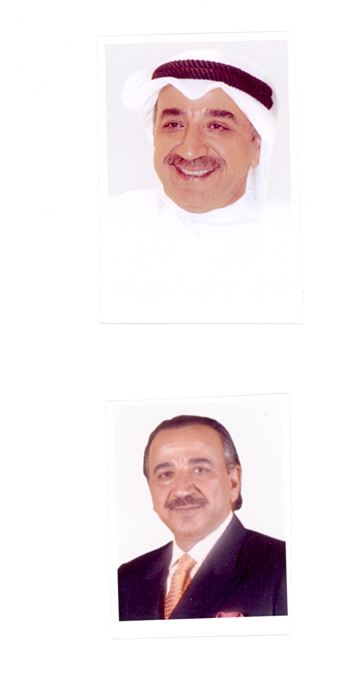
Curriculum Vitae
Abdul Hameed Abbas Dashti

- Born in Kuwait in 1954.
- Graduated from Kuwaiti Military College in 1974, started his career as a fighter and assumed many posts in the military field in the Kuwaiti Air Force and Air Defense till eventually retired from the military service in 1982.
- Joined many military training courses in different Arabic and Foreign states.
- Participated in many formal military delegates for many years.
- Studied commerce in Beirut University then dedicated his activities for managing his commercial works as a business man.
- Got Bachelor of laws from Alexandria University and Diploma & Doctoral Degree from Creativity University of France.
- Founder of the Kuwaiti Dashti Son Industry & Services Group and its Chairman.
- Chairman and Managing Director for many share holding companies in Kuwait including Marakez Real Estate Trade Centers Co. (k.s.c.c).
- Chairman of many companies in the Arab Republic of Syria - for example but not limited to – Investment Development Co., Damascus World Trade Center and other companies specialized in the field of Aviation, Insurance and Real Estate Development.
- Founder of the Reconstruction a Development Co. In Iraq since 2004.
- Established in Kuwait many specialized companies in the sectors; Catering, Contracting and Investment in the fields of Real Estate and Shares.
- Established many vocational federations for businessmen.
- Was appointed as the chairman of Services and Facilities in Hawaly Governorate within the first formation of these Counsels in Kuwait.
- Previous candidate for the National Assembly elections in Kuwait State in 1992.
- Played a distinguished role in the armed resistance formations during the brutal Invasion for Kuwait State in 1990.
- Holder of life membership in the World Arabian Horse Organization (WAHO).
- Member of the General Assembly and was elected as assistant General Secretary of the Kuwaiti Equestrian & Hunting Club when his highness the Amir was the Chairman of this Club.
- Assumed the position of Deputy Chairman Group VII in the International Equestrian Federation.
- Still assuming the position of the General Secretary of the Arabian Equestrian Federation.
- Chosen as the Honorary Consul of the Ivory Coast Republic in the State of Kuwait.
- Works as lawyer in the Cassation and the Supreme Constitutional Court in Kuwait.
- Member in the Arab Lawyers Union.
- In 2008 was chosen as member in the Arab Council Supporting Fair Trial (ACSFT) and Human Rights
- In 2008 was chosen as member in the Arab Organization for Human rights.
- In 2008 was chosen as the Chairman of the Syrian Palestinian Committee for supporting the Right of Return.
- A writer having a long history since he started writing on the general issues in the Kuwaiti Newspapers in the beginnings of the eighties, and his positions were always clear, explicit and direct.
- Chairman of the newspaper "Al Diwan" which is a distinguished daily electronic newspaper covering International and Arabic issues in Montreal, Canada. Currently he chairs many local, Arabic and international companied in the field of INFORMATION and CULTURE.
- He is a top public relations man so his writings are beneficial to gain from his wide domain culture and his inter-related relations with top figures that enable him to get important political information from its highest sources which are not available for many of the Arab writers.
- On April 2, 2011has been elected as the Secretary General of the "The General Conference to Support the People of Bahrain" held in the Iraqi Capital Baghdad.
- On July 27, 2011 has been elected as member in the General Secretariat of the Islamic and Arabic Rally supporting Resistance Option and Arabic Revolutions.
- On August, 2011 has been elected as President of the International Council Supporting Fair Trial and Human Rights in Geneva.
- On December, 2012 had been elected as a member in the Kuwait Parliament.
******************************************

